Click to enter a date

Choose an item Enter First & Last Name
[INSERT YOUR COMPANY’S NAME HERE]

Dear Choose an item Enter your last name

The North and South Carolina Oncology Association Board of Directors invites [INSERT YOUR COMPANY’S NAME HERE] to attend and display at our NCOA/SCOS 2023 Joint Conference on February 17-18, 2023 at the Charlotte Convention Center in North Carolina.

The $3,000 registration fee includes:
⊳ draped display table, no electricity
⊳ up to two (2) registrants, who may attend all open programming
⊳ exhibiting company recognized in the conference program
⊳ select your table from unassigned display tables

We anticipate 100 attendees to include physicians, physician assistants, nurse practitioners, pharmacists, and registered nurses.

NCOA is a 501(c)6, not for profit. The society’s tax identification number is 26-0085378. Please make your check payable to:

North Carolina Oncology Association
1801 Research Boulevard, Suite 400
Rockville, MD 20850

We ask that you direct questions to Lea Njosa at CorporateRelations@accc-cancer.org or by phone at 301.984.9496, ext. 225. We appreciate your support and thank you in advance for your participation.

Best Regards,
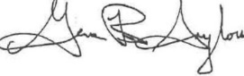
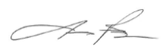
Jimmy Ruiz, MD & Gene B. Saylors, MD
President’s
North & South Carolina Oncology Association

