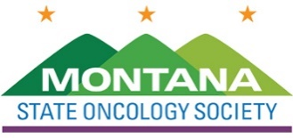

Click to enter a date

Choose an item Enter First & Last Name
[INSERT YOUR COMPANY’S NAME HERE]

Dear Choose an item Enter your last name

The Montana State Oncology Society (MSOS) Board of Directors invites [INSERT YOUR COMPANY’S NAME HERE] to attend and display among one of our MSOS Education Series.

The $2,500 registration fee includes:
⊳ draped display table, no electricity
⊳ up to two (2) registrants, who may attend all open programming
⊳ exhibiting company recognized in the conference program
⊳ select your table from unassigned display tables

We anticipate 100 attendees to include physicians, physician assistants, nurse practitioners, pharmacists, and registered nurses.

MSOS is a 501(c)6, not for profit. The society’s tax identification number is 32-0454325. Please make your check payable to:

The Montana State Oncology Society
1801 Research Boulevard, Suite 400
Rockville, MD 20850

We ask that you direct questions to Lea Njosa at CorporateRelations@accc-cancer.org or by phone at 301.984.9496, ext. 225.
We appreciate your support and thank you in advance for your participation.

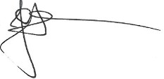
Best regards,
Jack Hensold, MD President
Montana State Oncology Society

