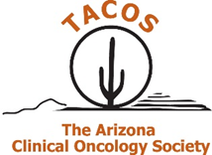

Click to enter a date

Choose an item Enter First & Last Name
[INSERT YOUR COMPANY’S NAME HERE]

Dear Choose an item Enter your last name

The Arizona Clinical Oncology Society (TACOS) Board of Directors invites [INSERT YOUR COMPANY’S NAME HERE] to attend and display at our TACOS 2023 Spring Conference on April 22, 2023 at The Scottsdale Resort at McCormick Ranch in Scottsdale, AZ.

The $3,000 registration fee includes:
⊳ draped display table, no electricity
⊳ up to two (2) registrants, who may attend all open programming
⊳ recognition in the conference program
⊳ opportunity to select your table from unassigned display tables

We anticipate 100 attendees to include physicians, physician assistants, nurse practitioners, pharmacists, and registered nurses.

TACOS is a 501(c)6, not for profit. The society’s tax identification number is 86-0684975. Please make your check payable to:

The Arizona Clinical Oncology Society
1801 Research Blvd, Suite 400
Rockville, MD 20850

Please direct questions to CorporateRelations@accc-cancer.org. We appreciate your support and thank you in advance for your participation.

Best Regards,
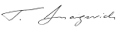
Tomislav Dragovich, MD, PhD
President
Arizona Clinical Oncology Society

