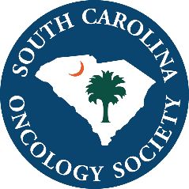

Click to enter a date

Choose an item Enter First & Last Name

Select company name

Dear Choose an item Enter your last name

The South Carolina Oncology Society (SCOS) Board of Directors invites Select company name to attend and display at our SCOS Fall Conference August 9-10, 2019 at Charleston Gaillard Center

in Charleston, SC.

The $2,200 registration fee includes:

⊳ draped, display table, no electricity

⊳ up to two (2) registrants, who may attend all open programming

⊳ your company recognized in the conference program

We anticipate 250 attendees to include physicians, physician assistants, nurse practitioners, pharmacists, and registered nurses.

SCOS is a 501(c)6, not for profit. The society’s tax identification number is **57-0732587**. Please make your check payable to:

South Carolina Oncology Society

1801 Research Blvd, Suite 400

Rockville, MD 20850

If you have any questions, contact Camille Walker at [**cwalker@accc-cancer.org**](mailto:cwalker@accc-cancer.org)or 301.984.9496, ext. 218.

We appreciate your support and thank you in advance for your participation.

Best Regards,



Emily Touloukian, DO

Board President